**Bungee Coding Round**

**Name : Sai Charan Karangula**

**Email :** [**karangulasai123@gmail.com**](mailto:karangulasai123@gmail.com)

**Language Used : MYSQL**

creating the databae named **bungee :**

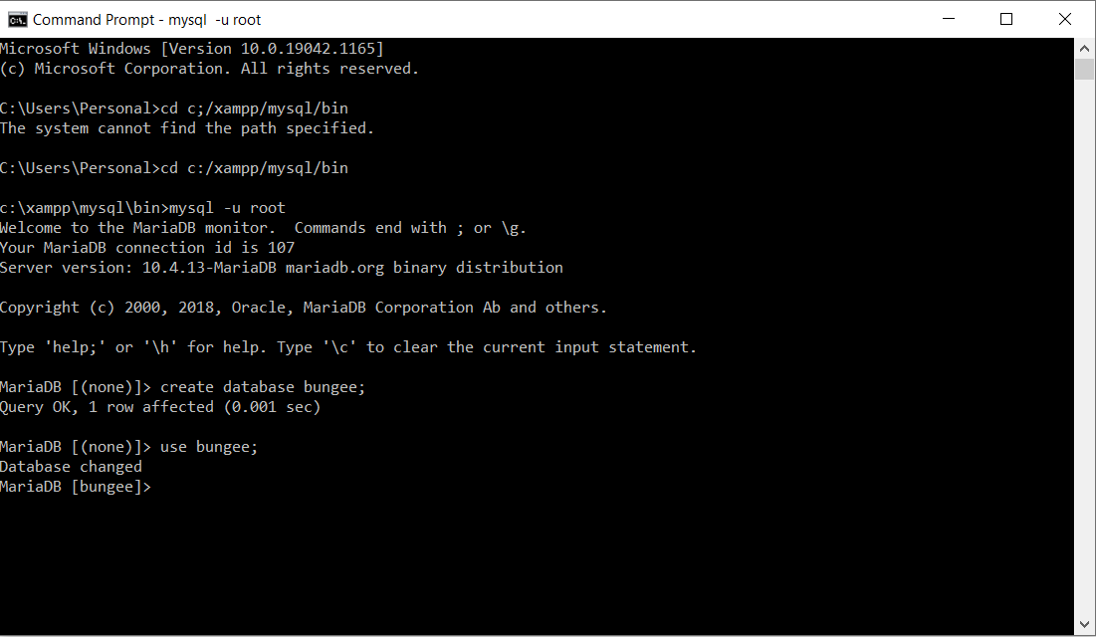

Creating table named as **main** with **9** **fileds** with data type varchar :

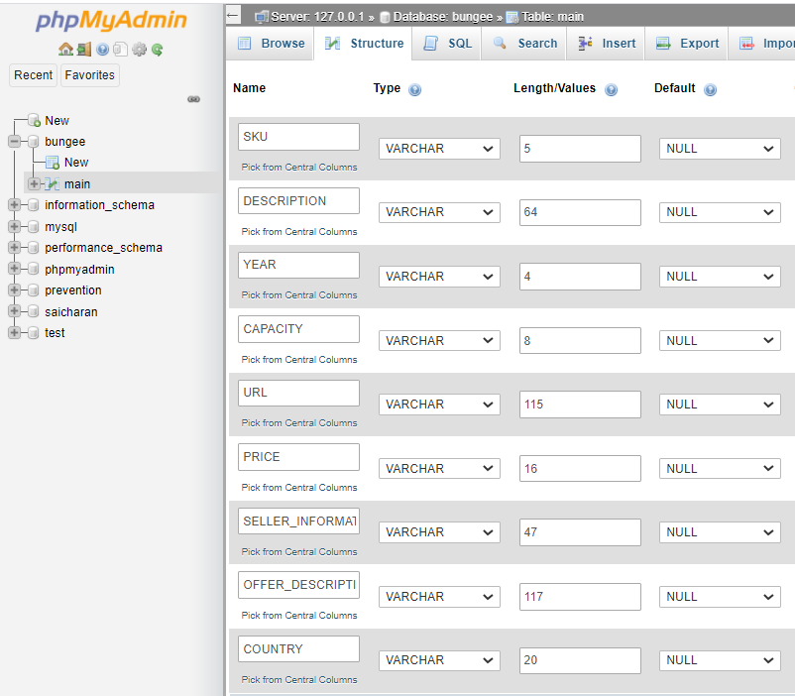

Import data into the **main** table :

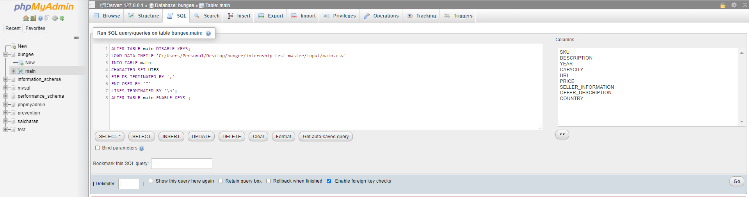

**11196** rows imported successfully :

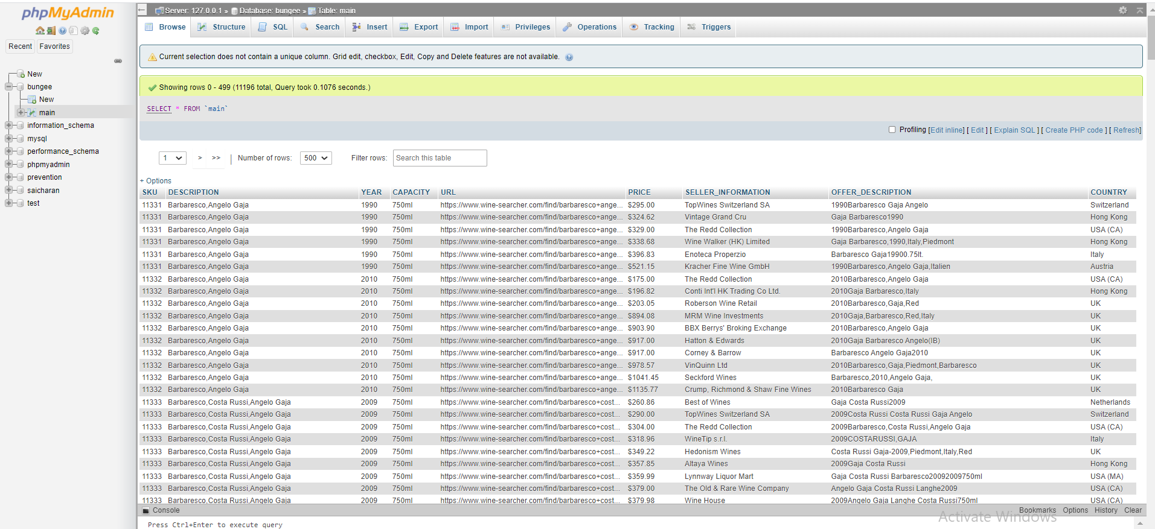

To solve the 1st problem :

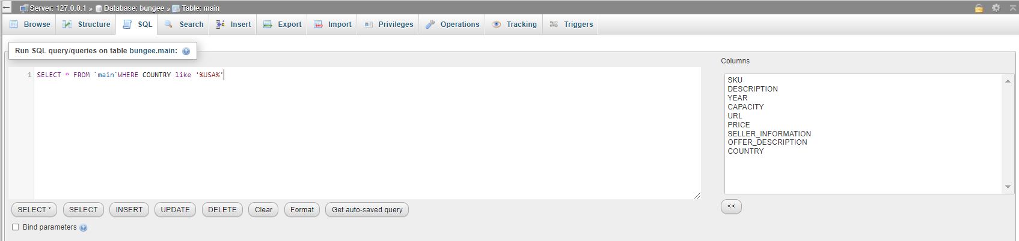

Table return **3030** rows successfully :

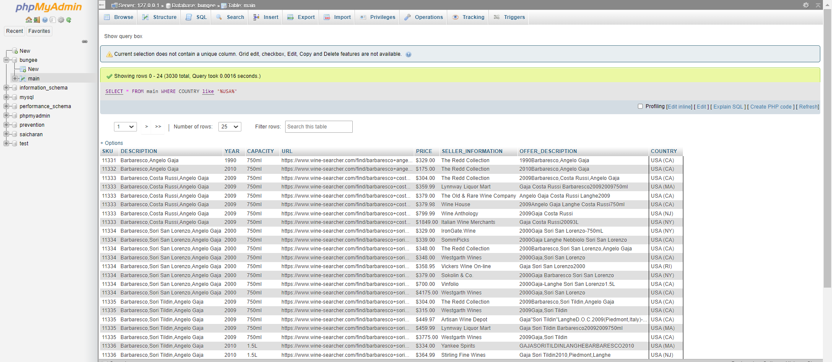

Creating table named as **filteredcountry** with **9 fileds** with data type **varchar** :



Import data into the **filteredcountry** table :

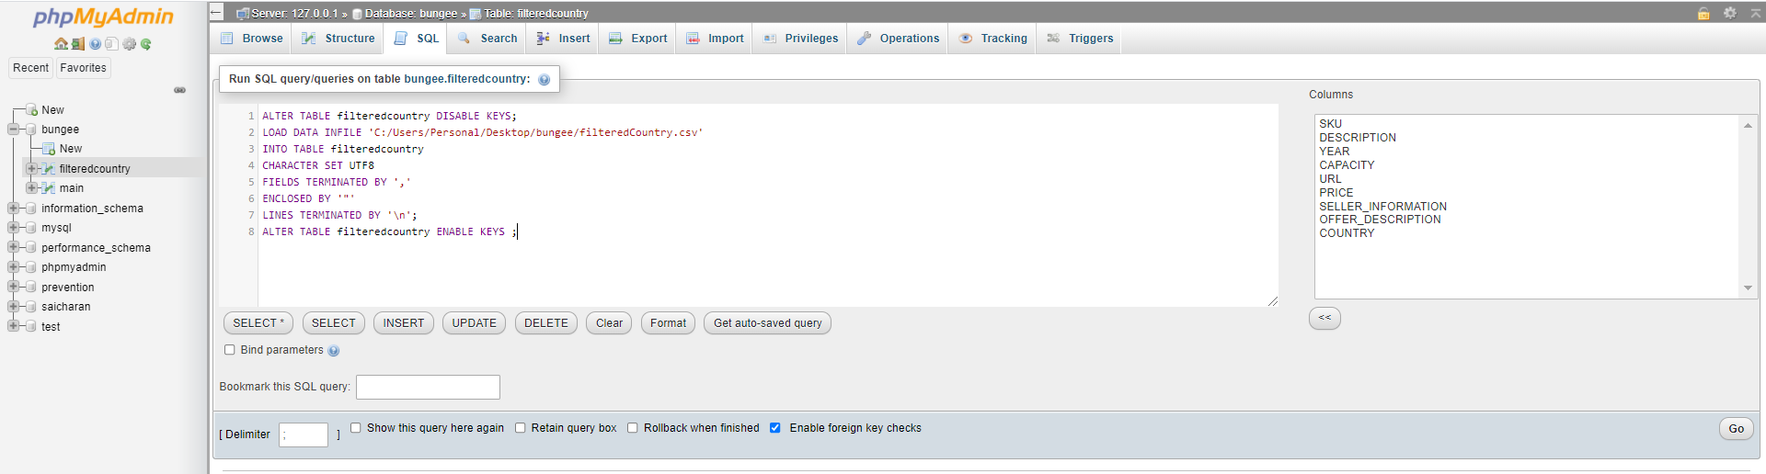

**3030** rows imported successfully :

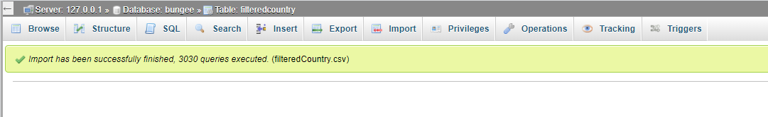

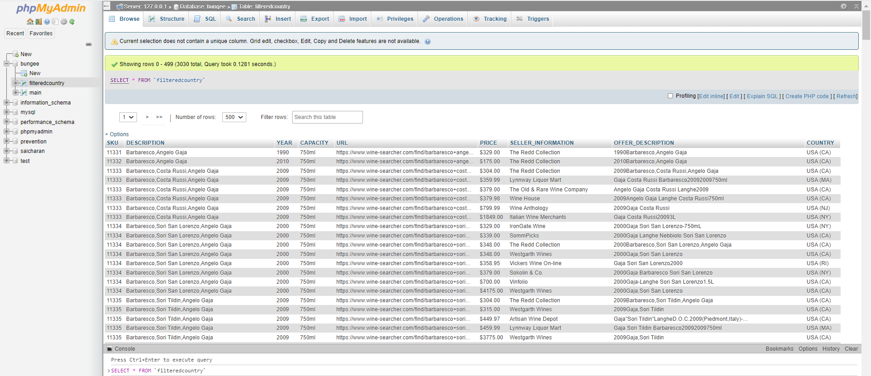

To solve 2nd problem :

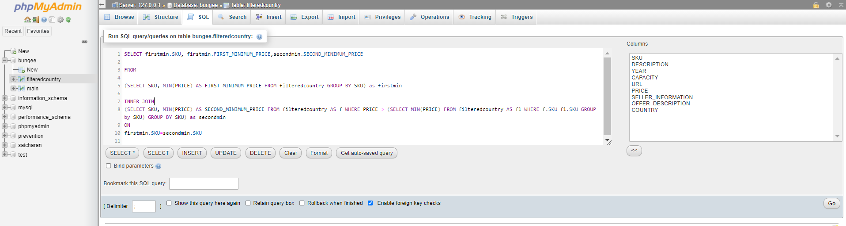

The database return the table with **271** **rows/tuples** successfully :

